**BFS**

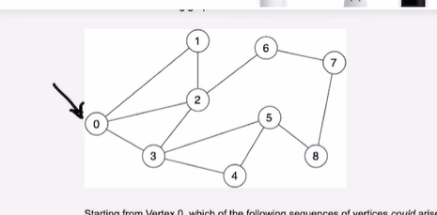

**Add ‘0’ to queue,add ‘0’ to visited..**

**QUEUE: 0**

**VISITED: 0**

**Pop ‘0’ from queue.**

**Add elements adjacent to ‘0’ which are ‘1’, ’2’ , ‘3’ to queue**

**And mark ‘1’, ’2’, ’3’ visited.**

**QUEUE: 123**

**VISITED: 0123**

**Pop ‘1’ from queue.**

**Adjacent elements ‘0’ and ‘2’ are in visited.**

**Don’t need to add any new value to the queue.**

**QUEUE: 23**

**VISITED: 0123**

**Pop ‘2’ from queue.**

**Adjacent elements are ‘6’ and ‘3’.**

**Since ‘3’ has been in visited, we add ‘6’ to the queue and mark ‘6’ as visited.**

**QUEUE: 36**

**VISITED : 01236**

**Pop ‘3’ from queue.**

**Adjacent elements are ‘2’, ‘4’, ‘5’.**

**‘2’ is in visied.**

**We just add ‘4’, ‘5’ to the queue.**

**QUEUE: 654**

**VISITED: 0123654**

**Similarly:**

**QUEUE: 547**

**VISITED: 01236547**

**Similarly:**

**QUEUE: 478**

**VISITED: 012365478**

**Similarly:**

**Pop ‘4’**

**Then pop’7’, then pop ‘8’**

**Finally:**

**VISITED: 012365478**

**FOR CODING:**

**CHESSBOARD TRAVERSAL (python)**